INSERT YOUR TITLE HERE USING UPPER CASE FONT AND DOUBLE-SPACE IF YOUR TITLE IS MORE THAN ONE LINE

By

Author’s full name

A Thesis Presented to

The Faculty of Humboldt State University

In Partial Fulfillment of the Requirements for the Degree

Master of Science in Natural Resources: insert your option here

Committee Membership

Type advisor’s full name (precede all names with “Dr.”), Committee Chair

Type committee member’s full name, Committee Member

Type committee member’s full name, Committee Member

Type committee member’s full name, Committee Member

Type graduate coordinator’s full name, Graduate Coordinator

Month Year

# ABSTRACT

INSERT YOUR TITLE HERE, WHICH SHOULD BE THE SAME AS THE ONE ON YOUR TITLE PAGE; SINGLE SPACE IF MORE THAN ONE LINE

Author’s full name

Start typing the text of your Abstract here. The Abstract should summarize the contents of your thesis and should be able to stand alone. Emphasis should be on what you found. Literature citations and footnotes are not allowed. The Abstract should include the following elements: 1) the key topic or problem, 2) your main approach (methods), 3) one or two important results, and 4) discuss/interpret your results or note your main conclusion. For examples of abstracts, see the Graduate Studies website and completed HSU theses on Humboldt Digital Scholar. Abstracts are read by those who are trying to decide whether or not to read the main document. Sometimes Abstracts are read by people who want to get the big picture before reading the main document. The Abstract should not exceed 250 words (approximately 1.5 pages). Page numbers (lower case Roman numerals) begin with the abstract. The title page is not numbered, but is assumed to be page “i.” Therefore page number “ii” is centered at the bottom of the first page of the Abstract.

# ACKNOWLEDGEMENTS

Acknowledgements are optional unless your study was funded. This is your chance to thank all of the people who helped you in designing, carrying out, and writing your thesis. If you received funding for your graduate research be sure to list the source of the funding and the grant/scholarship/fellowship number if there is one.

TABLE OF CONTENTS

ABSTRACT ii

ACKNOWLEDGEMENTS iii

LIST OF TABLES v

LIST OF FIGURES vii

LIST OF APPENDICES viii

INTRODUCTION 9

Heading Level Two (make sure ‘Heading 2’ is selected as the style) 10

Heading level Three 10

Heading Level Two 10

MATERIALS AND METHODS 12

Heading Level Two 12

Heading Level Two 12

Heading level Three 13

RESULTS 15

Heading Level Two 15

Heading level Three 17

Heading level Three 17

Heading Level Two 20

Heading Level Two 20

DISCUSSION 22

Heading Level Two 22

Heading level Three 22

CONCLUSIONS, RECOMMENDATIONS OR SUMMARY 23

REFERENCES OR LITERATURE CITED 24

Appendix A 25

Appendix B 26

# 

# LIST OF TABLES

Note: The Table of Contents, List of Tables, and List of Figures are automatic. There is no need to type anything into them. When you have finished adding all text to the template, simply single-click in the Table of Contents to select it, then right-click to open the menu options. Select the option “Update Field” and fill in the circle “Update Entire Table,” then click “OK.” This template has insured use of the appropriate style (e.g., Heading 1 etc.) to your headings in the text, therefore headings and page numbers and will update in the TOC without you having to do anything. **Delete this text box when you are done** **with these instructions**.

Table 1. Table captions should describe the contents of the table. For example, a suitable caption for this table could be: "Bat species detected with automated ultrasonic detectors placed within 50 m of black cottonwood saplings, and percentage of identified bat passes (*n* = 895) at Mono Lake, California.” 16

# LIST OF FIGURES

Figure 1. Example of a site map showing the study site locations and an inset regional map of California. To insert a caption for each of your figures, first select the graphic, then go to the "References" tab and choose 'insert caption.’ Type a detailed caption into the dialog box and choose 'Below selected item' for the position. You should indent ½ inch after the first line, single space and you can use a font size smaller than 12-point if you prefer (but be consistent about the font size of your captions throughout). 14

Figure 2. Make sure text within a figure is readable and clear. A caption for the above figure might be: “Biomass (mg-100 leaves) for arthropod foraging functional groups and number of concealment structures-100 leaves (mean ±1 SE; n = 28 for each treatment and census combination) on black cottonwood saplings to which birds and bats did (control) and did not (exclosure) have access at Mono Lake, California.” 18

Figure 3. Figures placed in landscape orientation can keep the page number in the upper right corner. Example caption for this figure: “Transformed linear regression vascular plant volume models (Y = β1X1 + ε) and box plot comparison of estimated and 19

# LIST OF APPENDICES

Appendix A: Instructions for Appendices 25

Appendix B: Number of arthropods-100 leaves leaves (mean ± standard deviation, n = 28 saplings per treatment and census combination) on black cottonwood saplings at Mono Lake, California, 2010. 26

# INTRODUCTION

Insert the text of your Introduction here. Each heading level one (e.g. INTRODUCTION) should be all caps and start on a new page. Be sure to check for misspellings in your header because Microsoft Word does not check the spelling of words in all caps. Be aware that you can designate a header as level 1, 2, 3 or 4 in the ‘styles’ section of the Home tab. If you add or remove headings or other text entries in your document, you can quickly update the Table of Contents by going to the **References** tab in the **Table of Contents** section; click “**Update Table**” and then click “**Update entire table**.” For more information on headings, styles and how to use the auto-update Table of Contents, go to the Graduate Studies website under “Thesis/Project Help” or <http://www.humboldt.edu/gradprograms/node/17>.

The Introduction section should set the context for the work to be reported. It should also establish the purpose and importance of that work and answer the question, “What did you study?” Per the State of California’s Title 5 Education Code, this is where you might “clearly identify the problem, state the major assumptions, [and] explain the significance of the undertaking.” Begin with a broad scope and then narrow the focus of the Introduction as it progresses. The Introduction should demonstrate the author’s awareness of the pertinent literature (or you can have a separate section called “Literature Review” after the Introduction). It is good practice to end your Introduction with a statement of your study objectives.

Masters theses should be typed in a standard typeface using 12-point characters. Times New Roman 12-point is the font of choice. You may reduce the font size within tables or figures to fit within margins. However, keep the font type consistent throughout your document.

Text must be double spaced, except for quoted passages that may be indented and single-spaced for emphasis and within the Table of Contents or List of Figures/Tables when a heading or caption title wraps to a second line. Text must be left aligned.

## Heading Level Two (make sure ‘Heading 2’ is selected as the style)

If you want to have sub-headings within one of your major sections (i.e. Introduction, Methods, Results, Discussion) use heading level two: center aligned; the first letter of each major word is capitalized, and has spacing set at 12 points before and 18 points after.

### 

### Heading level Three

Heading level three is left aligned; the font is underlined and sentence case. There is a double space to the text that follows.

Heading level Four. (paragraph heading). This heading is indented with the paragraph. The font is underlined and in sentence case. The heading ends with a period.

## Heading Level Two

Scientific names may be denoted by underlining or by italics (e.g., Neophylax rickerii or *Neophylax rickerii*). However, underlining or italics must be applied consistently throughout the thesis. The genus should be abbreviated after its first use (e.g. *N. rickerii*) but must always be spelled out in its entirety when used as the first word in a sentence (e.g., *Neophylax rickerii*).

# MATERIALS AND METHODS

Insert the text of your Materials and Methods here. The Materials and Methods section describes what you used (Materials) and how you did your study (Methods). Alternatively, you can call this section simply “METHODS.” This section must be sufficiently detailed so that a reasonably competent colleague would be able to repeat your work. Reproducibility is an essential cornerstone of the scientific method. This section should include your research design or approach; population and/or sample; collection and tabulation of data; and data analysis procedures. Be sure to avoid unnecessary details about common laboratory equipment (e.g. microscopes, balances, notebooks, etc.) and procedures (e.g. standard statistical analyses).

## Heading Level Two

If you worked with vertebrate animals, your Institutional Animal Care and Use Committee (**IACUC**) approval number and date must be included in your materials and methods. If you worked with Human Subjects in your research, your Institutional Review Board (**IRB)** approval number and date must be included in your materials and methods.

## Heading Level Two

Your materials and methods may require a detailed description of the study site. Limit the study site information to that needed for an understanding and interpretation of the results. The study site section can be a sub-section within your Materials and Methods or it can be a stand-alone section just before the Materials and Methods section. It is always a good idea to provide a site map of where you conducted your study (see Figure 1 for an example). You should cross-reference each mention of your figures and tables in the text by highlighting the text (e.g., Figure 1), go to the ‘References’ tab, and click on ‘Cross reference’ in the Captions section. In the drop-down menu ‘insert reference to’ you should choose ‘only label and number.’ All tables and figures must be referred to in the text. The figure or table should be inserted immediately after the paragraph when it is first mentioned. Tables and figures must be cited in the text in numerical order. Each table/figure should be placed on a separate page or immediately following the paragraph where it is first mentioned (if it can fit on the same page).

### Heading level 3

#### Heading level 4.

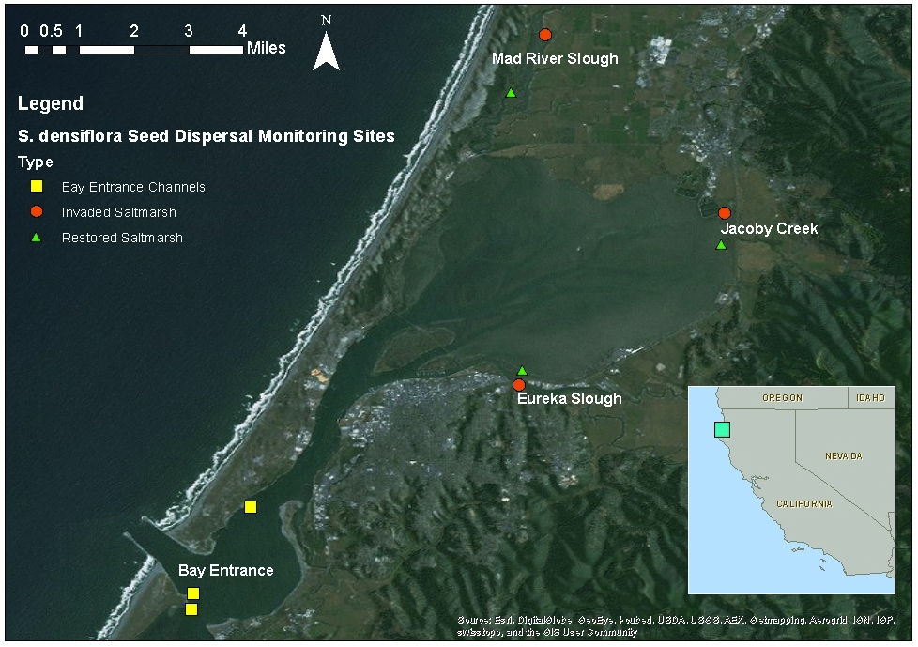

Figure 1. Example of a site map showing the study site locations and an inset regional map of California. To insert a caption for each of your figures, first select the graphic, then go to the "References" tab and choose 'insert caption.’ Type a detailed caption into the dialog box and choose 'Below selected item' for the position. You should indent ½ inch after the first line, single space and you can use a font size smaller than 12-point if you prefer (but be consistent about the font size of your captions throughout).

# RESULTS

Insert the text of your Results here. In the Results section you present your findings. This is harder than it seems because often you are presenting data. Sometimes, data can be effectively presented in tables or figures. However, anything you present must be meaningful and should never be redundant. That is, you do not have to present every scrap of data. And you should not present the same data in a table and figure. If you present the majority of data in a table, use the text to point out the highlights from that table.

## Heading Level Two

When inserting a table, use the ‘Insert Table’ tool in Word to create accessible tables in your document. Tables should have clear column headings to provide context and assist in navigation of the table’s contents. Identify the top row of the table as a header row in Table Properties. If the table spans more than one page, check “Repeat as header row at the top of each page” in Table Properties. Do not use tabs or spaces to create tables. It may look like a table; however, it will not be accessible or readable by assistive technologies. Do not merge or split cells. Do not use the Draw Table tool in Word to create tables. Do not copy and insert tables as pictures or figures. Table captions are placed above the table and figure captions are placed below the figure (see Table 1 for an example). Tables should have horizontal lines consistent with the format shown in Table 1.

Table 1. Table captions should describe the contents of the table. For example, a suitable caption for this table could be: "Bat species detected with automated ultrasonic detectors placed within 50 m of black cottonwood saplings, and percentage of identified bat passes (*n* = 895) at Mono Lake, California.”

|  |  |  |
| --- | --- | --- |
| Common name | Scientific name | Percentage of identified bat passes (%) |
| Small-footed myotis | *Myotis ciliolabrum* | 37.0a |
| Little brown bat | *Myotis lucifugus* | 31.3 |
| Long-eared myotis | *Myotis evotis* | 23.5 |
| Big brown bat | *Eptesicus fuscus* | 4.2 |
| Free-tailed bat | *Tadarida brasiliensis* | 3.0 |
| Silver-haired bat | *Lasionycteris noctivagans* | 1.4 |
| California myotis | *Myotis californicus* | <1b |
| Hairy-winged myotis | *Myotis volans* | <1 |
| Yuma myotis | *Myotis yumanensis* | <1 |
| Pallid Bat | *Antrozous pallidus* | <1 |

a: Percentages are weighted means.

b: A percentage <1 indicates a low detection rate.

### Heading Level Three

If a table is too long for one page it may be continued on the next and following pages by repeating the same caption followed by "continued" in parentheses. All column headings must be repeated exactly on each continuation page.

Leave enough space between columns so that each entry stands out as a separate item. Leave at least one space on each side of the longest entry. Align columns of words on the left; align numbers by decimal points or by centering the column. Single-space within items and double space between items. Footnotes may be placed 12 points below the bottom of a table. Use lower case letters to identify footnotes.

### Heading Level Three

Figures presented in your Results section should have high enough resolution to be read and understood easily (at least 300-600 dpi). A color image should be able to be interpreted if printed in black and white as well. Figure 2 and Figure 3 are more example figures.

#### Heading Level Four.



Figure 2. Make sure text within a figure is readable and clear. A caption for the above figure might be: “Biomass (mg-100 leaves) for arthropod foraging functional groups and number of concealment structures-100 leaves (mean ±1 SE; n = 28 for each treatment and census combination) on black cottonwood saplings to which birds and bats did (control) and did not (exclosure) have access at Mono Lake, California.”

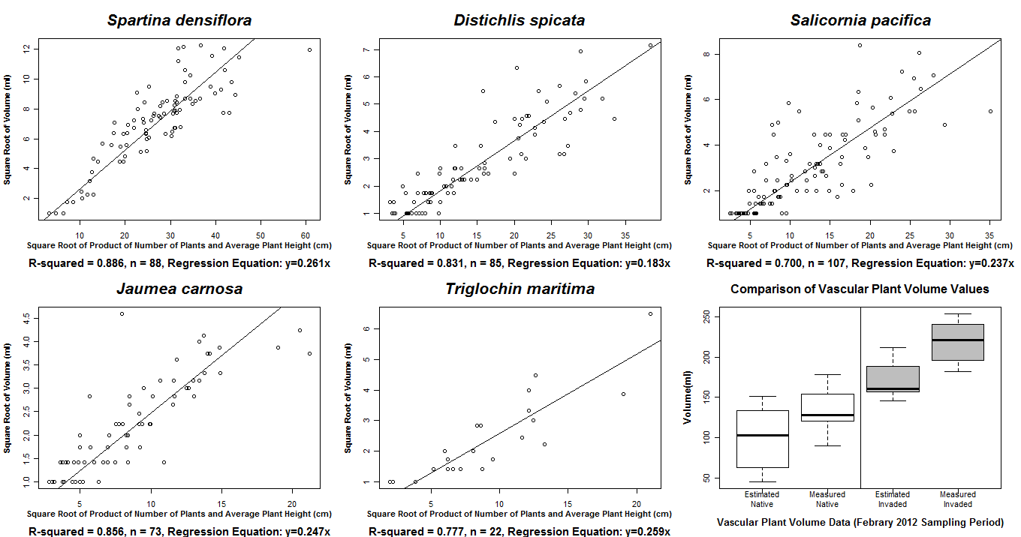

Figure 3. Figures placed in landscape orientation can keep the page number in the upper right corner. Example caption for this figure: “Transformed linear regression vascular plant volume models (Y = β1X1 + ε) and box plot comparison of estimated and

measured vascular plant volume in native and invaded plots.”

## Heading Level Two

In scientific writing, one digit numbers are usually given word names (e.g. one, two, etc.) when mentioned in the text. Two or more digit numbers are not spelled out (e.g. 10, 11, etc.). A fraction is always spelled out in the text unless it is part of a mixed fraction that is large enough to be expressed by numerals. Numerals are used to express quantities combined with abbreviations and symbols.

Decimals and percentages are expressed in Arabic numerals. Note that unless it follows a number (e.g., 50%), “percent” or “percentage” is correct. Use “%” only in tables and figures. For table entries with a value less than one, always precede the decimal point with a "0" (e.g. 0.24 not .24).

All reported measurements and units should be metric (if this is the convention in your discipline). Abbreviations of units should be consistent and standard. Avoid the use of periods after abbreviations (cm not cm.). Be consistent in your usage. If you use cm for centimeters, use m for meters.

Acronyms should be used sparingly. Spell out the acronym the first time it is mentioned (e.g., “Data were acquired by the United States Department of Agriculture (USDA)”) and then use the acronym for every subsequent mention.

## Heading Level Two

Direct quotations are discouraged but allowed. Short quotations must be enclosed in quotation marks and referenced. Place the closing quotation mark outside a comma or period but inside a colon or semicolon (e.g., “spiders.” and “spiders” ;). Place the quotation mark outside or inside of an exclamation point or question mark depending upon whether the mark belongs with the quoted material or with your text. Indicate omissions of parts of quoted material by three dots (e.g., "Read my lips no new ... "). Direct quotations of four typewritten lines or more should be set off in a separate paragraph(s), single-spaced, and referenced. The entire quotation should be inset equivalent to the indentation of a paragraph.

# DISCUSSION

Insert the text of your Discussion here. This is your chance to compare and contrast the results of your experiment or study with the previously published works of others. It also gives you a chance to present the principles, relationships, and generalizations shown by your results. You should, however, discuss and interpret your results, not just summarize your results. You should also point out any inconsistencies, exceptions, or lack of correlation in your results and offer possible explanations. Practical or theoretical implications of your work should also be noted. The Discussion section is also the appropriate place to make recommendations for future research (if not included in a separate section).

## Heading Level Two

Insert additional Discussion text here.

### Heading Level Three

Insert additional Discussion text here.

Heading Level Four.

# CONCLUSIONS, RECOMMENDATIONS OR SUMMARY

Conclusions, recommendations or a summary may be included after the Discussion. However, it is not required. Recommendations might be particularly appropriate if the work was done for a sponsoring agency to solve some problem in resource management. If you select ‘Summary’ as your header for this section you should summarize the entire research effort.

# REFERENCES OR LITERATURE CITED

Insert references here, with the first line of a reference left justified to the margin and all subsequent lines of that reference indented about 0.5 inches.

References are listed in alphabetical order by the first author’s last name. If a single author has multiple publications, list them chronologically by date of publication. If two publications appear in the same year, use (Tinker 1988a) and (Tinker 1988b). Please check with your committee and style manual for specific requirements.

An example of a basic outline for most references cited is: author(s), publication year, title, publication, volume, and page numbers. Ultimately you should use the reference format of your discipline (check formats of journals that fit your thesis topic).

There are usually more mistakes in the Literature Cited section than in any other section of most theses. Proofread this section carefully. Check every citation against the original article for accuracy.

References cited in the body of the thesis must be cited in the Literature Cited. Likewise, every reference cited in the Literature Cited must be used in the body of the text.

Cite references in the text using Name and Year (e.g., Smith 2008). When multiple references are cited (e.g., Tinker 1988, Evers 2001, Chance 2012) list them in chronological order. If Tinker published two papers in 1988, they may be cited as (Tinker 1988a) and (Tinker 1988b).

When a paper has three or more authors, it should be cited in the body of the thesis as Cobb et al. 2013. Note that “et al.” stands for “et alia,” which is Latin for “and others.” The et is not abbreviated, so it is not followed by a period. The al. is abbreviated so it is followed by a period. All authors must be listed in the Literature Cited.

You may substitute “in press” for the year if the paper has been accepted for publication, but volume and page numbers are not yet available.

Personal communications must be cited in the text, but do not need to be cited in your References/Literature Cited list. An in-text citation of a personal communication should be the person’s first initial, followed by their last name, pers. comm., and the year in which the communication was made (e.g., J. Smith, pers. comm., 2014).

# Appendix A

Appendix A: Instructions for Appendices

Appendices are used to include material too detailed or lengthy for inclusion in the body of the study (e.g., raw data, questionnaires, maps, photos, letters of permission). Each appendix is labeled alphabetically (e.g., APPENDIX A, APPENDIX B, etc.). If you include appendices, a LIST OF APPENDICES should follow LIST OF FIGURES.

Tables and figures in the appendix may be placed horizontally or vertically on the page. If the table/figure is aligned vertically, the caption must be aligned vertically.

# Appendix B

Appendix B: Number of arthropods -100 leaves (mean ± standard deviation, n = 28 saplings per treatment and census combination) on black cottonwood saplings at Mono Lake, California, 2010.

| Arthropod group | Control 1 | Exclosure 1 | Control 2 | Exclosure 2 | Control 3 | Exclosure 3 | Control 4 | Exclosure 4 |
| --- | --- | --- | --- | --- | --- | --- | --- | --- |
| Neuroptera | 0.001±0.006 | 0 | 0.002±0.009 | 0.004±0.013 | 0.016±0.041 | 0.007±0.017 | 0.005±0.020 | 0.002±0.010 |
| Hymenoptera | 0.26±0.43 | 0.68±1.67 | 0.24±0.29 | 0.37±0.55 | 0.73±1.74 | 0.53±0.81 | 1.76±6.63 | 1.22±2.10 |
| Sawfly Larvae | 0.004±0.015 | 0 | 0 | 0.01±0.04 | 0.03±0.10 | 0.03±0.06 | 0.03±0.05 | 0.01±0.04 |
| Sawfly Adult | 0 | 0.003±0.015 | 0.01±0.03 | 0 | 0.02±0.07 | 0.001±0.004 | 0 | 0.004±0.017 |
| Formicidae | 0.26±0.43 | 0.68±1.67 | 0.23±0.29 | 0.36±0.56 | 0.68±1.73 | 0.49±0.82 | 1.73±6.63 | 1.14±2.08 |
| Trichoptera | 0 | 0 | 0 | 0 | 0.003±0.018 | 0 | 0 | 0 |
| Lepidoptera Larvae | 0.01±0.05 | 0.01±0.02 | 0.01±0.03 | 0.03±0.08 | 0.07±0.19 | 0.25±0.81 | 0.03±0.04 | 0.03±0.04 |
| Lepidoptera Adult | 0.003±0.015 | 0 | 0.002±0.007 | 0.004±0.022 | 0.02±0.05 | 0.01±0.04 | 0.003±0.010 | 0.004±0.013 |
| Mecoptera | 0 | 0 | 0 | 0 | 0 | 0 | 0 | 0.001±0.005 |
| Diptera | 0.15±0.15 | 0.14±0.14 | 0.22±0.33 | 0.18±0.20 | 0.29±0.35 | 0.15±0.17 | 0.30±0.30 | 0.36±0.36 |
| Orderunknown | 0 | 0 | 0.004±0.020 | 0.01±0.04 | 0 | 0 | 0 | 0.01±0.02 |
| Herbivores | 4.15±4.58 | 4.79±4.60 | 7.91±18.05 | 7.70±17.13 | 31.70±89.61 | 20.05±55.06 | 26.03±123.36 | 18.49±37.72 |
| Detritivores | 5.15±4.51 | 4.79±4.60 | 6.91±11.05 | 21.70±17.00 | 22.16±44.32 | 15.63±11.30 | 16.44±29.94 | 11.83±13.30 |
| Plecoptera | 0.001±0.006 | 0 | 0.002±0.009 | 0.004±0.013 | 0.016±0.041 | 0.007±0.017 | 0.005±0.020 | 0.002±0.010 |
| Chewers | 0.02±0.05 | 0.01±0.02 | 0.01±0.04 | 0.04±0.08 | 0.11±0.20 | 0.29±0.81 | 0.06±0.06 | 0.04±0.05 |